**Ecommerce**

**Case Study: Enhancing E-Commerce Strategies through Data Analytics**

**Background**

As an analyst at Digital Commerce Insights, a consultancy focused on e-commerce optimization, you have access to two pivotal datasets: 'Ecommerce Orders' and 'Customer Profiles'. The 'Ecommerce Orders' dataset offers detailed insights into customer orders, including products purchased, quantities, unit prices, order dates, and shipping costs. Meanwhile, the 'Customer Profiles' dataset provides rich information on customer demographics, such as email, country, membership type, and spending history.

In an e-commerce landscape where customer preferences, purchasing behavior, and efficient order fulfillment play crucial roles, your analytical prowess is vital. Your challenge is to dissect these datasets to uncover patterns and insights that could revolutionize e-commerce strategies, improve customer engagement, and drive sales growth.

**Objective**

Your mission is to utilize Tableau's robust capabilities to craft a compelling narrative from the provided datasets. This task will encompass thorough data preparation, intelligent data modeling, and the skillful application of calculated fields and Tableau functions for sophisticated analysis. The ultimate aim is to construct an interactive and intuitive dashboard in Tableau that showcases your key discoveries, offering concise, actionable insights into the optimization of hotel operations and performance.

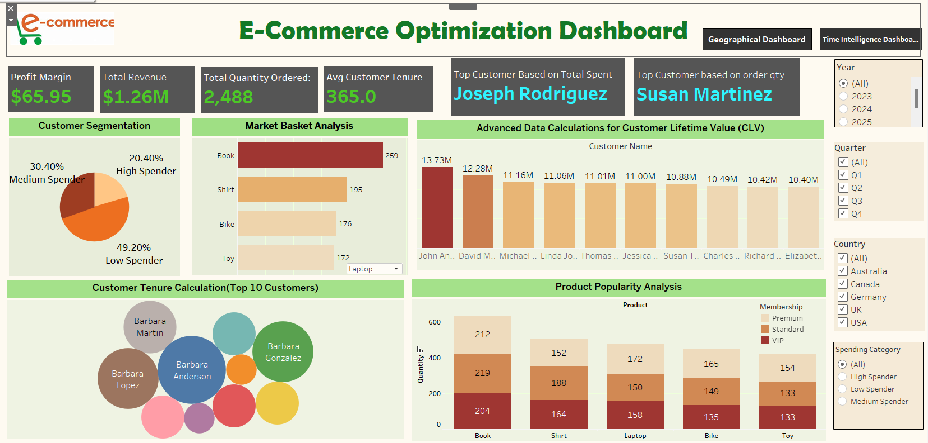

**1.Customer Segmentation**: Segment customers based on their 'TotalSpent' into categories like 'High Spender', 'Medium Spender', 'Low Spender'. Define the thresholds for these categories.

**Customer Segmentation Summary**

49.20% Low Spenders (spend < 5000)

30.40% Medium Spenders (spend 5000-7999.99)

20.40% High Spenders (spend ≥ 8000)

**Insights**

Low Spenders: Largest group; consider promotions and loyalty programs to boost spending.

Medium Spenders: Significant potential for upselling and personalized offers.

High Spenders: Smallest but most valuable group; focus on retention and exclusive offers.

**Strategic Actions**

Marketing: Tailor strategies to each segment (promotions for low, upselling for medium, retention for high spenders).

Resource Allocation: Invest more in high-value customers.

Product Development: Use insights to inform product offerings and inventory.

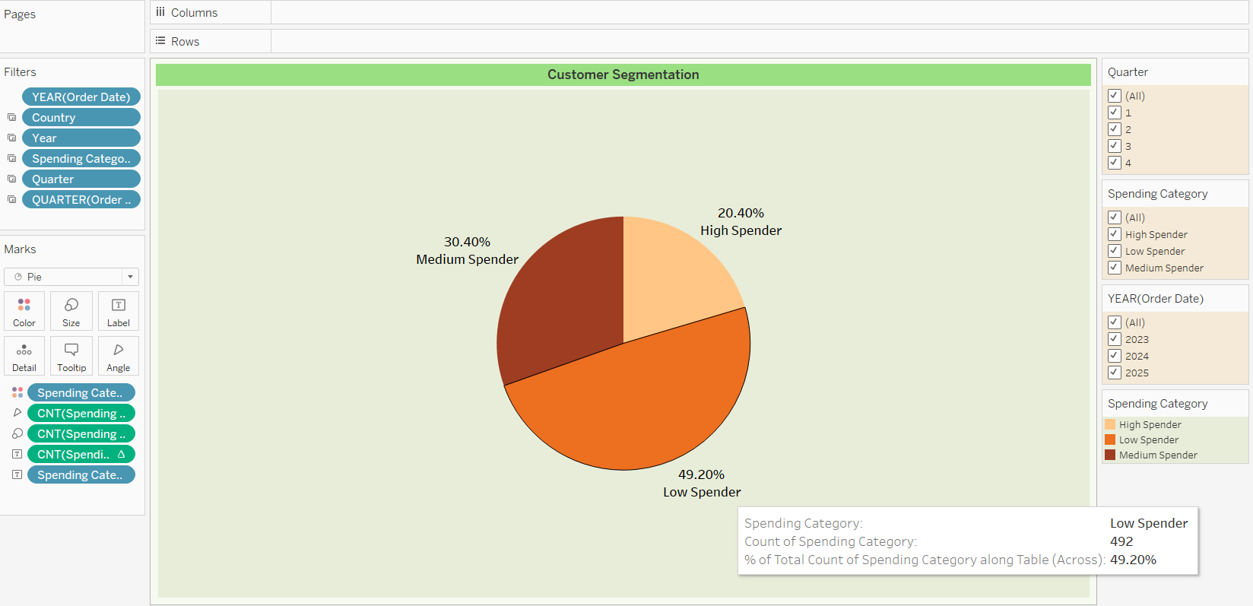This segmentation helps optimize marketing efforts, improve customer satisfaction, and drive revenue growth.

**Formula used:**

Profit Margin= (Unit Price×1.2)/(Unit Price−Shipping Cost) ×100

**Insights**

1.High Profit Margin (73.6%)

Interpretation: Indicates efficient cost management and healthy markup.

Actionable Insight: Replicate successful practices to maintain high margins across products.

2.Low Profit Margin (-423.2%)

Interpretation: Indicates a loss due to high shipping costs or other inefficiencies.

Actionable Insight: Investigate and address causes of losses, such as reducing shipping costs or adjusting pricing strategies.

**General Insights**

Margin Variability: Wide range indicates varying cost structures and pricing efficiency.

Cost Management: Focus on minimizing costs to ensure profitability.

Product Analysis: Evaluate products with extreme margins to identify best practices or issues.

**Conclusion**

Understanding profit margins helps optimize pricing, control costs, and improve profitability. Address negative margins and replicate high-margin practices to enhance financial performance.

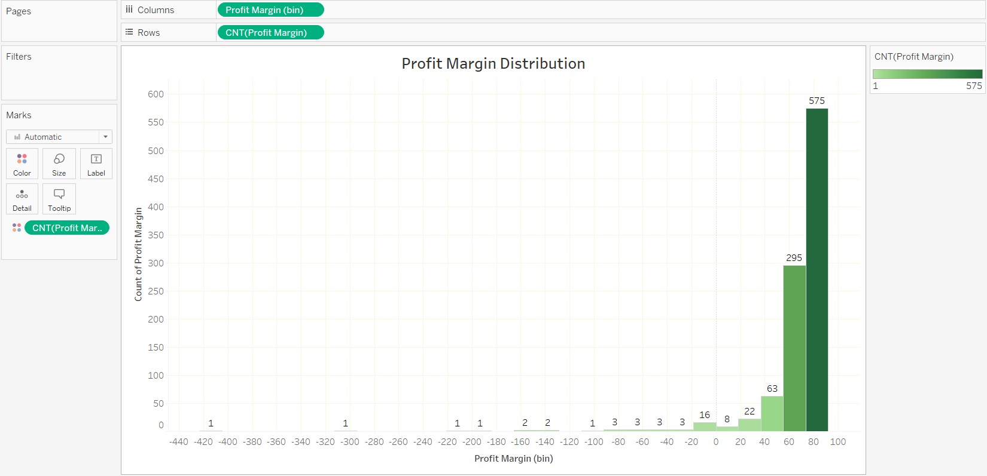

**3.Product Popularity Analysis**: Identify the most and least popular products based on the quantity ordered.

Analysis of Membership Types and Spending

**Key Findings**

Books: Most popular across all memberships. Premium: 212 orders. Standard: 219 orders. VIP: 104 orders

Toys: Least popular across all memberships. Premium: 154 ordersStandard: 133 orders. VIP: 133 orders

**Insights**

Product Popularity: Books: Highest demand. Toys: Lowest demand.

**Actionable Strategies**

**Promotions**:

Books: Bundle deals and bulk purchase discounts.

Toys: Introduce discounts and promotions to boost interest

**Product Development:**

Leverage book popularity strategies for other products.

Use feedback to improve toy offerings.

**Conclusion:** Tailor marketing strategies and promotions based on membership spending patterns to boost sales and customer satisfaction.

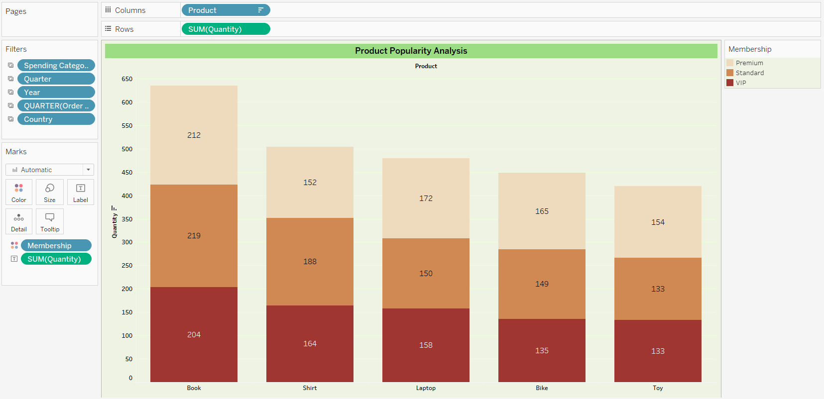

**4.Country-Based Analysis:** Compare the average order value and total quantity ordered by customers from different 'Countries'.

**UK:**

Avg. Order Value: $4.97k (219 orders)

Insight: High order volume but slightly lower average spend compared to Canada.

**Canada:**

Avg. Order Value: $5.03k (176 orders, lowest)

Insight: Highest average spend among analyzed countries, but lower order volume.

**Actionable Insights**

UK: Focus on increasing average spend through upselling and promotions.

Canada: Encourage more frequent purchases to boost order volume despite high average spend.

**Conclusion**

Tailor marketing strategies based on country-specific spending patterns to optimize sales and customer engagement.

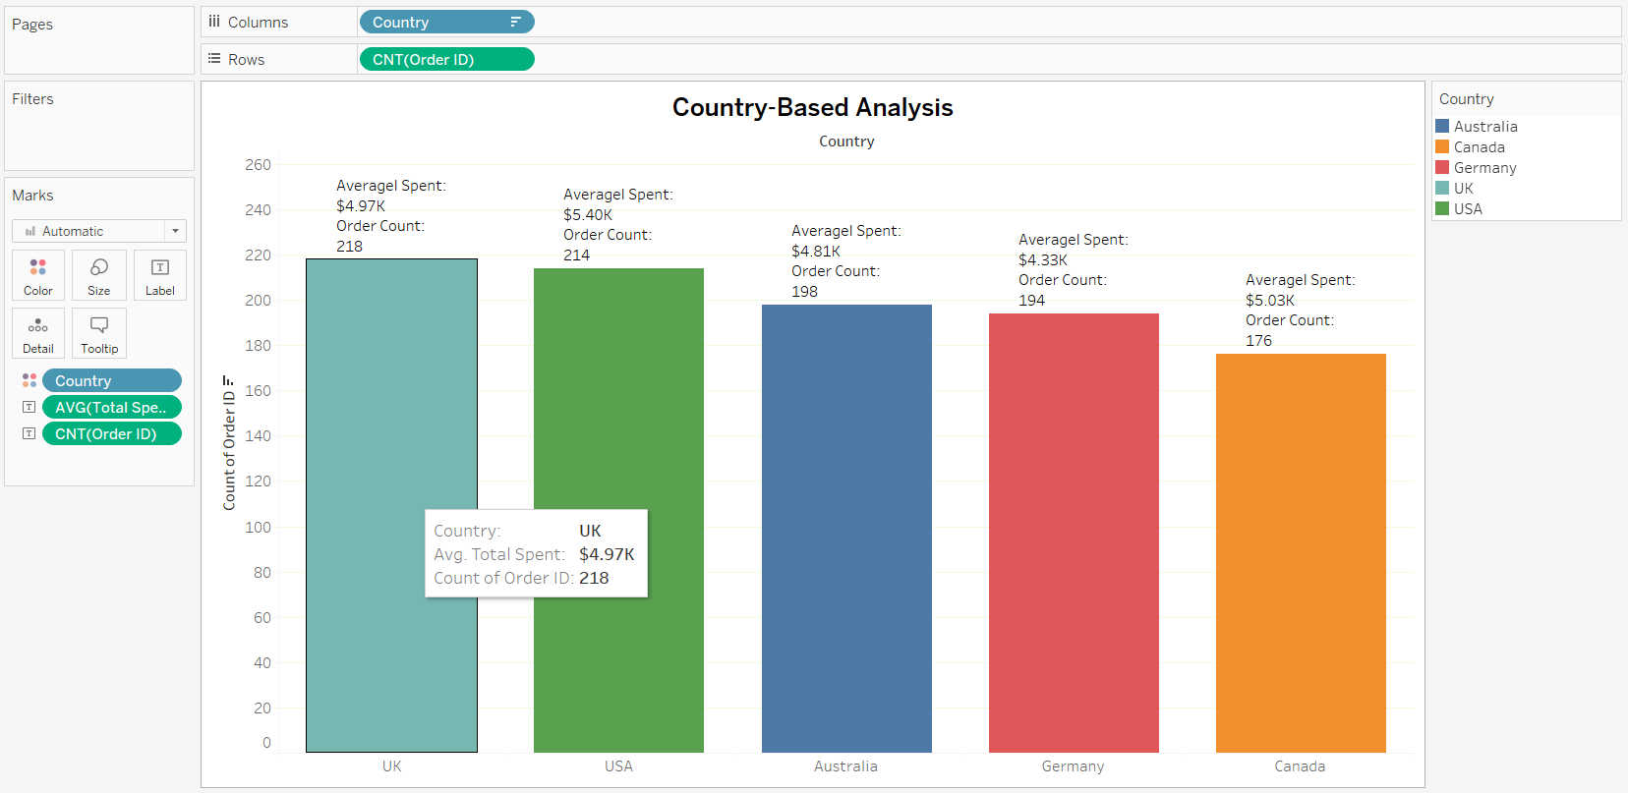

**5.Order Frequency Analysis**: Calculate the frequency of orders per customer. Who are the top repeat customers?

Top Repeat Customer: **Joseph Smith (20 orders)**

Insight: Joseph Smith demonstrates significant loyalty with a high order frequency.

**Key Insights**

Customer Loyalty: Identifying top repeat customers like Joseph Smith highlights the importance of customer retention strategies.

Targeted Marketing: Tailoring marketing efforts towards top repeat customers can enhance customer satisfaction and drive business growth.

Feedback and Engagement: Engaging with loyal customers provides valuable insights into their preferences, enabling the business to improve its offerings and services.

**Actionable Strategies**

Customer Recognition: Implement loyalty programs or special offers to reward and retain top repeat customers.

Personalized Communication: Develop personalized marketing campaigns to nurture customer relationships and encourage repeat purchases.

Continuous Improvement: Use customer feedback to continuously refine products and services, ensuring alignment with customer needs and preferences.

**Conclusion**

Understanding and leveraging the loyalty of top repeat customers like Joseph Smith is crucial for driving long-term success and growth in the business. By implementing targeted strategies and fostering meaningful relationships, the business can strengthen customer loyalty and enhance its competitive position in the market.

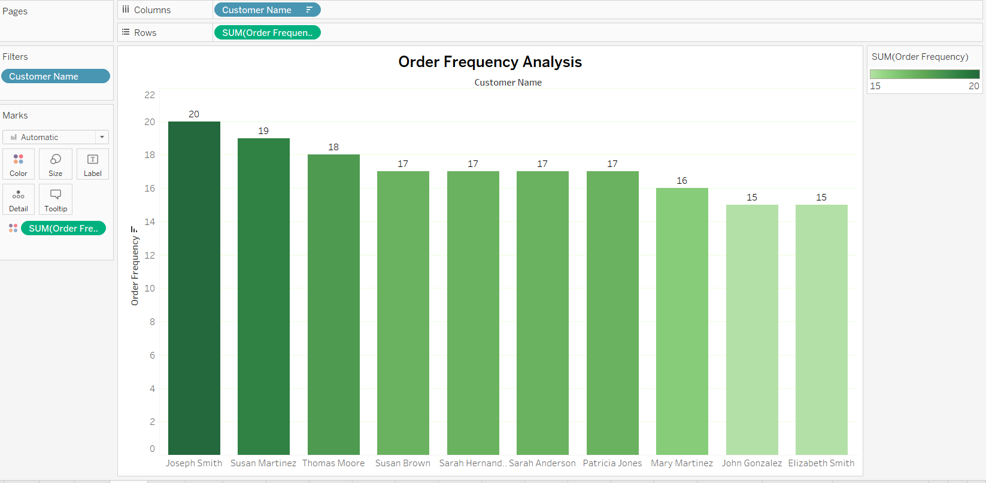

**6.Analysis of Membership Types**: Analyze the distribution of orders across different 'Membership' types. Do certain membership types tend to spend more?

**Membership Types: Premium, Standard, VIP**

Premium Membership: Total Orders: 342, Avg. Spend: $5.01k.

Standard Membership : Total Orders : 334,Avg. Spend: $4.97k

VIP Membership: Total Orders: 324, Avg. Spend: $4.76k

**Insights**

Premium Members: Highest average spend and order count among all membership types.

Standard Members: Similar order count to Premium but slightly lower average spend.

VIP Members: Lowest average spend despite a relatively high order count.

**Actionable Insights**

Premium Members: Target with premium offerings and personalized incentives to maintain their high spending.

Standard Members: Encourage to spend more through targeted promotions or loyalty programs.

VIP Members: Investigate reasons for lower spending and implement strategies to increase average spend.

**Conclusion**

across membership types allows for tailored marketing and retention strategies to maximize revenue and customer satisfaction.

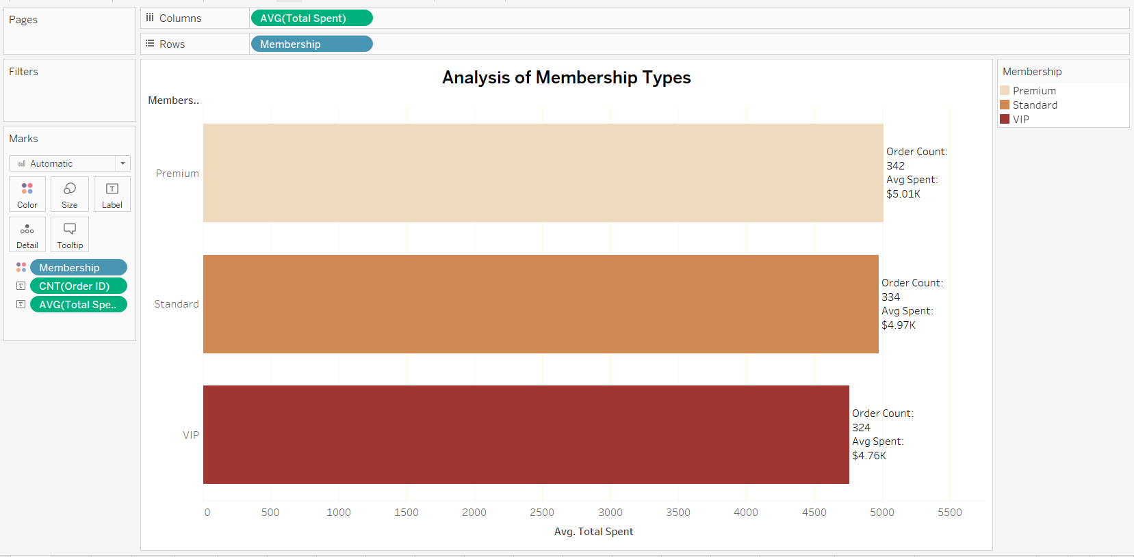

**7.Cohort Analysis**: Perform a cohort analysis based on the 'Sign Up Date' of customers. How does the spending behavior vary among different cohorts?

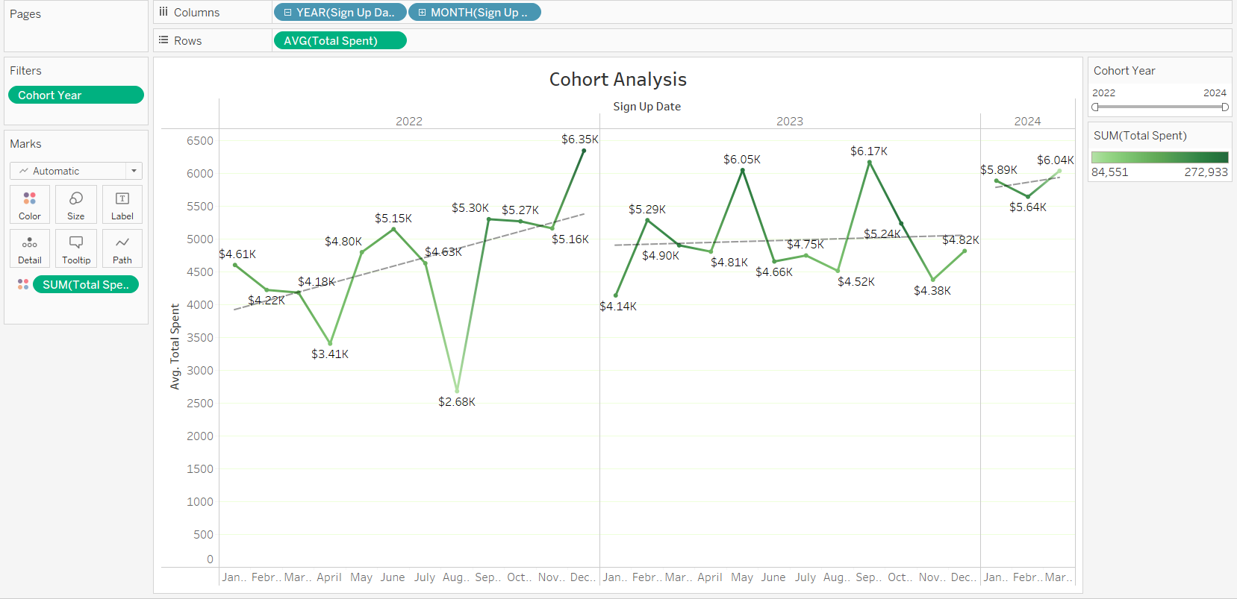

**8.** **Customer Tenure Calculation**: Calculate the tenure of each customer from their 'Sign Up Date' to the current date.

Customer Tenure Analysis

Using the formula DATEDIFF ('day', [Sign Up Date], [Last Order Date]), Barbara Anderson has the highest customer tenure, with a tenure of 1.83k days.

**Insights**:

**Barbara Anderson**: Demonstrates remarkable loyalty and long-term engagement with the business, with a tenure of approximately 1.83k days.

**Actionable Insights:**

Customer Retention: Recognize and reward long-term customers like Barbara Anderson to maintain their loyalty and strengthen customer relationships.

Personalized Engagement: Tailor communication and offers to Barbara Anderson and other long-tenured customers to enhance their experience and encourage continued loyalty.

Retention Strategies: Implement strategies to retain customers with shorter tenures, focusing on improving satisfaction and incentivizing repeat purchases.

**Conclusion:**

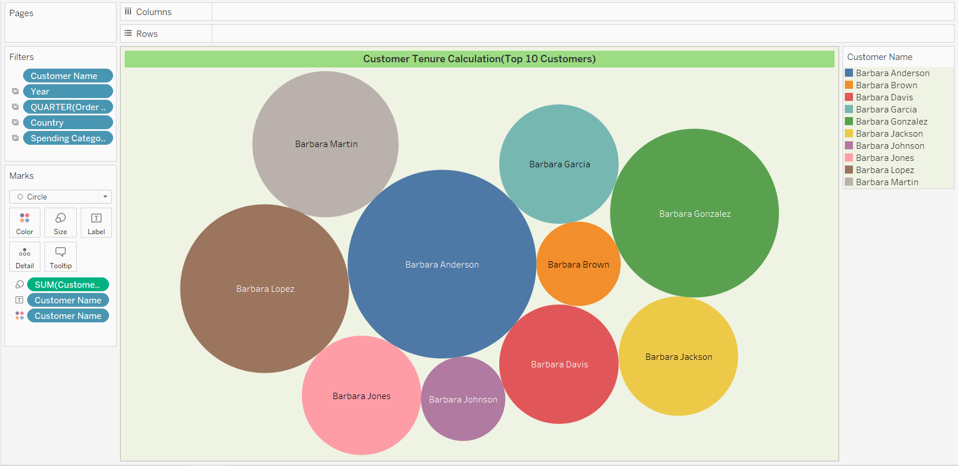Barbara Anderson's extended tenure highlights the importance of customer loyalty and the potential value of long-term customer relationships. By prioritizing customer retention efforts and fostering meaningful connections with customers like Barbara Anderson, the business can drive sustained success and growth.

**10.Time-Series Analysis of Orders**: Analyze the trend of orders over time. Are there noticeable seasonal effects or trends?

**Trends Over Time:**

January to August: Constant order count.

August to December: Decreasing order count.

**Notable Changes:**

August: Order count starts to decrease, with **93** orders.

September: Further decrease to **86** orders.

October to December: Consistent order count around 62.

**Insights:**

Seasonal Effects: Noticeable decrease in order count from August to December suggests a seasonal trend.

Actionable Insights:

1.Seasonal Promotions: Plan targeted promotions or campaigns to stimulate sales during slower periods and capitalize on peak seasons.2.Customer Engagement: Focus on enhancing customer engagement and satisfaction to maintain sales momentum during slower periods.

Conclusion:

Analyzing the trend of orders over time reveals notable seasonal effects, with a decrease in order count observed from August to December. By understanding and adapting to these seasonal trends, the business can optimize its operations and strategies to maximize sales and customer satisfaction throughout the year.

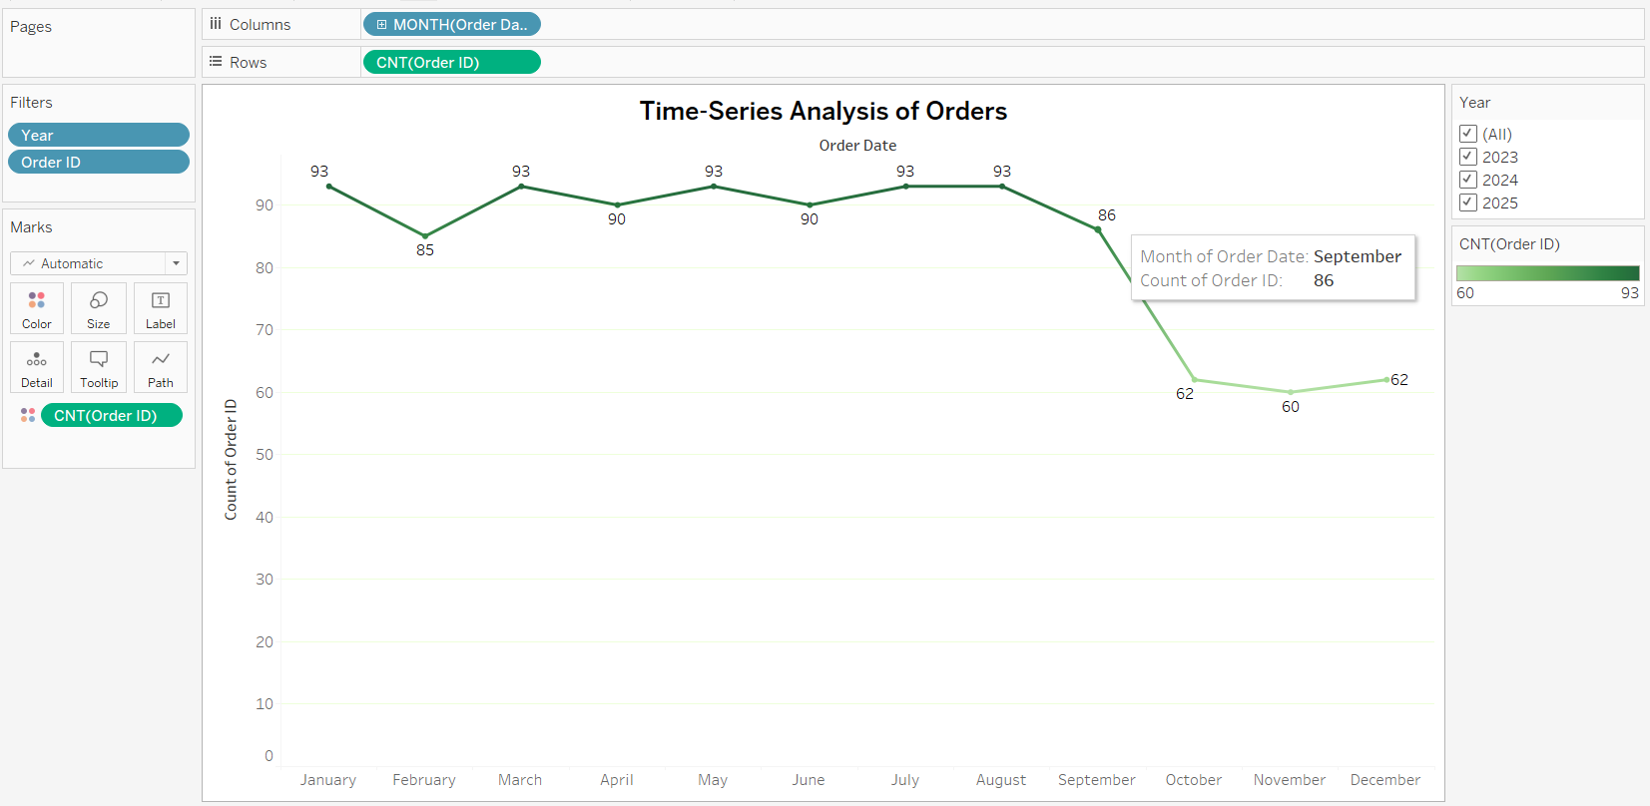

**11.Aggregate Analysis of Shipping Cost**: Calculate the average shipping cost per product. Are there products with significantly higher shipping costs?

Average Shipping Cost per Product:

Bike: Average shipping cost of $53.85k.

Toy: Least average shipping cost of $47.93k.

**Insights:**

High Shipping Cost for Bikes: Bikes incur the highest average shipping cost, indicating larger size or weight, or more complex shipping requirements.

Lowest Shipping Cost for Toys: Toys have the lowest average shipping cost, possibly due to their smaller size and lighter weight.

**Actionable Insights:**

Shipping Optimization: Explore opportunities to optimize shipping processes for products with higher shipping costs, such as bikes, to reduce expenses and improve efficiency.

Pricing Adjustments: Consider adjusting product prices to account for differences in shipping costs, ensuring profitability while remaining competitive.

Product Packaging: Evaluate packaging strategies to minimize shipping costs for larger or heavier items, potentially through more efficient packaging designs or bulk shipping arrangements.

**Conclusion:**

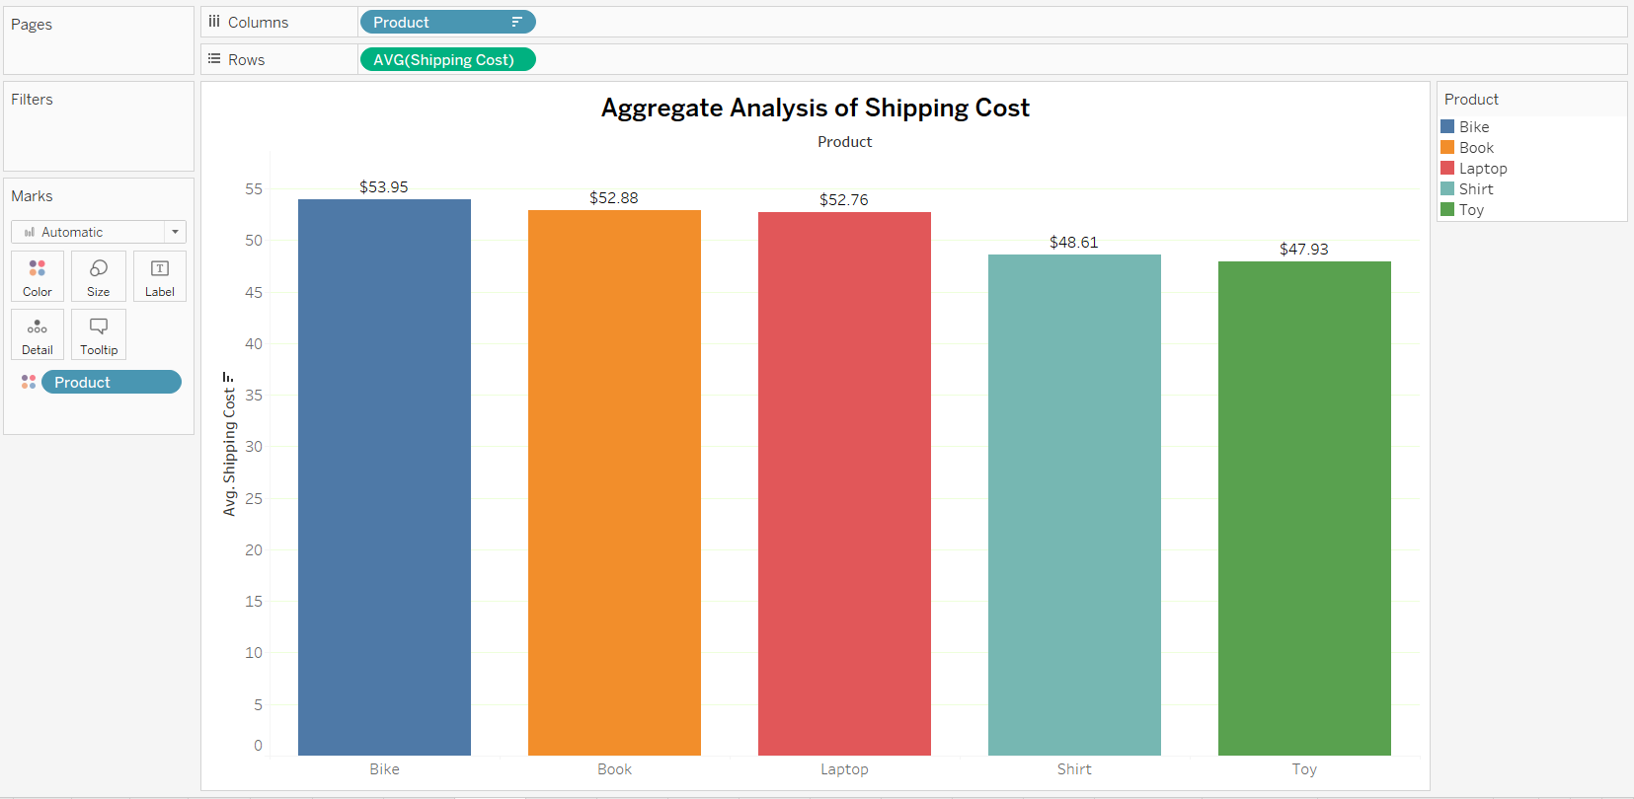Analyzing average shipping costs per product reveals significant disparities, with bikes having the highest average shipping cost and toys the lowest. By understanding these variations and implementing appropriate strategies, the business can optimize shipping operations and ensure cost-effective delivery of products to customers.

**12.Analysis of Customer Communication Logs**: Use text analysis to identify common themes in the 'Customer Communication Log'. What are the frequent issues or inquiries?

**Product Information Requests:**

1.Tokenized Log 64: Customers seeking more information about products or services.

Payment Issues:

2.Tokenized Log 62: Customers reporting problems or issues related to payments.

**Insights:**

Product Information Requests: Indicates a need for clearer product descriptions or additional information to assist customers in making informed purchasing decisions.

Payment Issues: Highlights potential challenges with payment processing systems or billing procedures that require attention and resolution.

**Actionable Insights:**

Enhance Product Information: Update product descriptions and provide comprehensive information to address customer inquiries and improve transparency.

Resolve Payment Issues: Investigate and resolve payment-related issues promptly to ensure a seamless purchasing experience for customers.

**Conclusion:**

Analyzing customer communication logs reveals common themes such as product information requests and payment issues. By addressing these issues proactively and implementing appropriate solutions, the business can enhance customer satisfaction, improve operational efficiency, and drive overall business success.

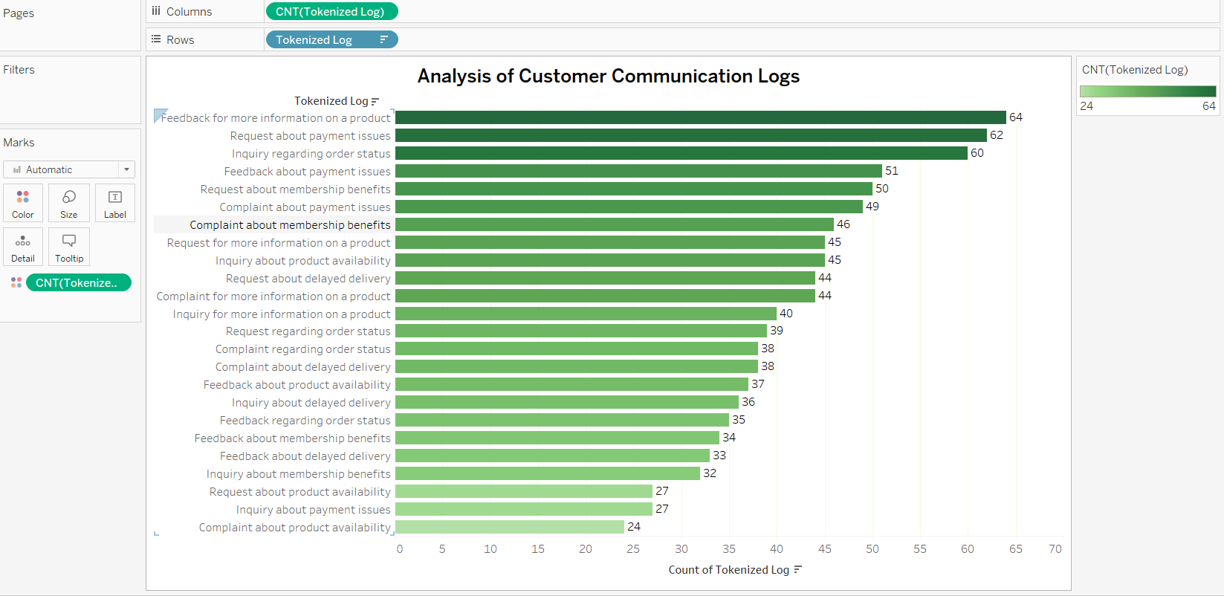

**13.Predictive Analysis for Future Spending**: Use trend lines to predict future spending patterns of customers. How reliable are these predictions?

**Trend Analysis:**

January 2023: Average total spent = $5,913

January 2024: Average total spent = $5,977

January 2025: Average total spent = $5,502

January 2026: Average total spent = $4,600

**Insights:**

Trend: Gradual decrease in average spending over time.

**Reliability:**

Mixed: Trend lines offer insights, but external factors can impact predictions unpredictably.

**Actionable Insights:**

Monitor Factors: Stay updated on economic and market trends.

Adapt Strategies: Flexibility in adjusting marketing approaches.

Customer Engagement: Enhance personalized experiences to maintain loyalty.

**Conclusion:**

While trend analysis guides future predictions, staying agile and customer-focused is crucial for adapting to changing market dynamics.

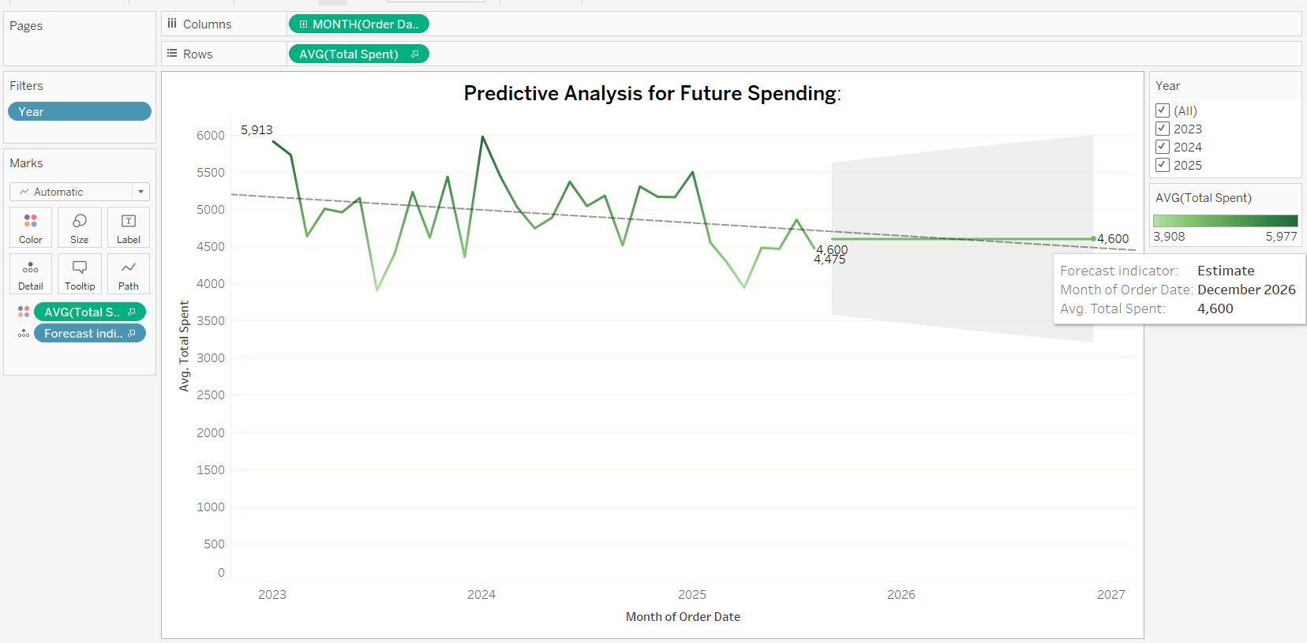

**14.Product and Membership Correlation**: Investigate if there's a correlation between the types of products purchased and the membership status of customers.

Products Purchased:

Bike: 165 Premium, 49 Standard, 135 VIP

Book: 212 Premium, 219 Standard, 204 VIP

Toy: 154 Premium, 133 Standard, 133 VIP

**Insights:**

Premium Members: Higher purchases across all product categories compared to Standard and VIP members.

Standard Members: Second highest purchases, particularly in books.

VIP Members: Generally lower purchases compared to Premium and Standard members.

**Actionable Insights:**

Targeted Marketing: Tailor marketing campaigns based on membership status to promote relevant products and services.

Membership Tier Benefits: Consider offering exclusive benefits or discounts on specific product categories to incentivize higher spending among different membership tiers.

Product Assortment: Adjust product assortment and inventory management strategies based on the purchasing preferences of different membership segments.

**Conclusion:**

By understanding the preferences of different membership segments, businesses can optimize their offerings and enhance customer satisfaction and loyalty.

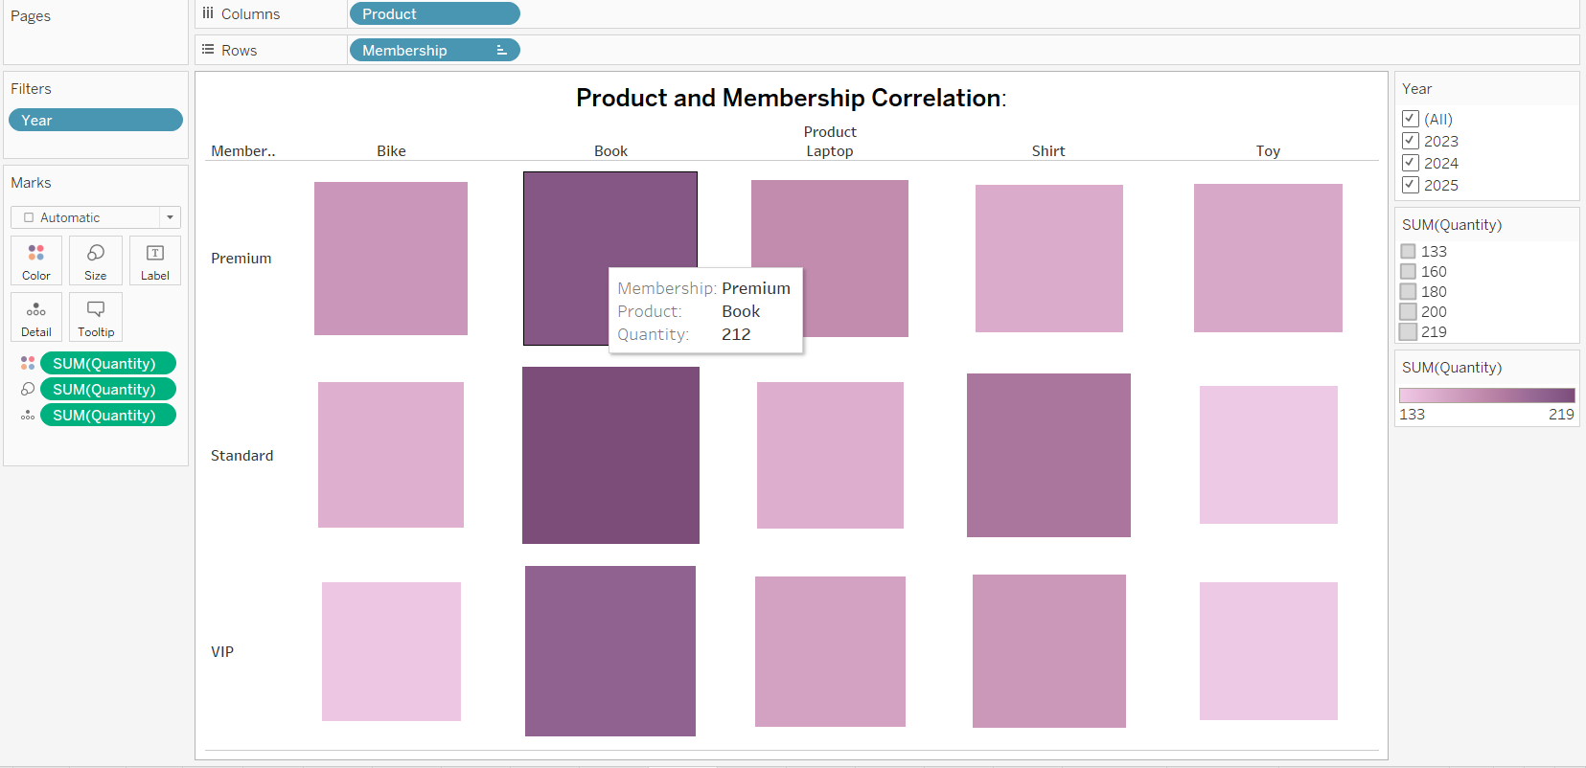

**15.Clustering for Customer Segmentation:** Use clustering to group customers based on spending patterns, order frequency, and membership type.

**Cluster 1**:Total Spent per Customer: $10,000 , Order Frequency: Order Frequency 1

**Cluster 2:**Total Spent per Customer:

Cluster 1: $19,778 (Order Frequency 2)

Cluster 2: $29,643 (Order Frequency 3)

Cluster 3: $38,074 (Order Frequency 4)

Cluster 4: $46,524 (Order Frequency 5)

**Insights:**

Cluster 1: Customers with lower spending and order frequency.

Cluster 2: Customers with higher spending and order frequency, showing a positive correlation between spending and order frequency.

**Actionable Insights:**

Targeted Marketing: Tailor marketing strategies based on the characteristics of each cluster to maximize effectiveness and ROI.

Customer Engagement: Implement personalized communication and loyalty programs to enhance customer retention and satisfaction within each cluster.

Product Recommendations: Recommend relevant products or services based on the preferences and behavior of customers in each cluster.

**Conclusion:**

By leveraging these insights, businesses can optimize marketing efforts, improve customer satisfaction, and drive overall business growth.

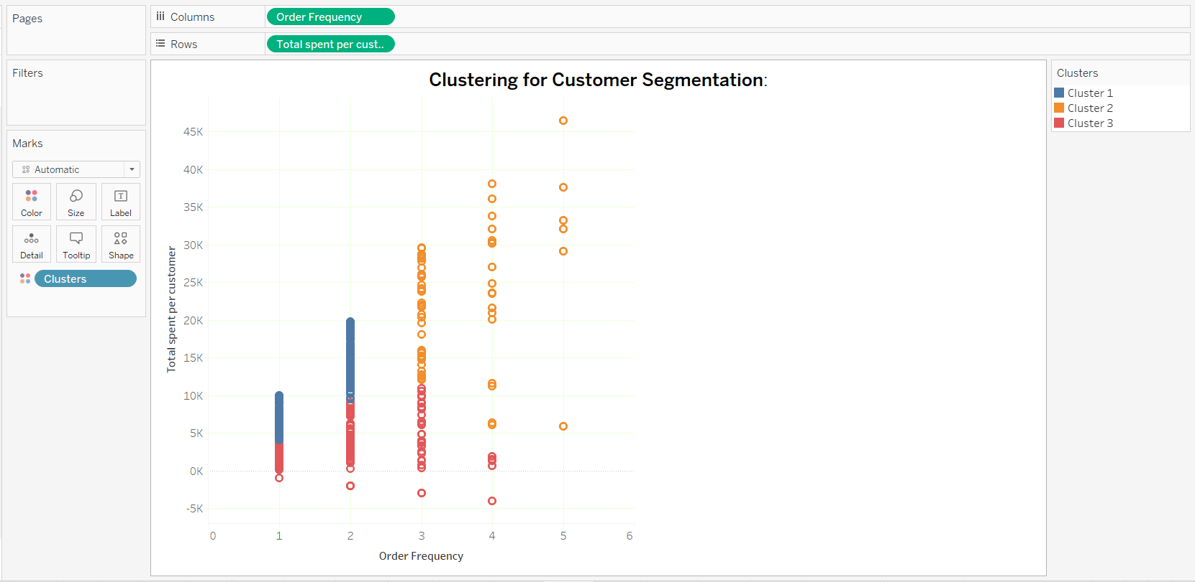

**16.Advanced Data Calculations for Customer Lifetime Value (CLV)**: Develop a calculated field to estimate the CLV of each customer. Consider factors like order frequency, average order value, and tenure.

**Conclusion**

Calculating Customer Lifetime Value (CLV) by considering order frequency, average order value, and customer tenure provides a comprehensive measure of a customer's overall value to the business.

**This approach allows for:**

Identification of High-Value Customers: Enabling the business to focus on retaining and nurturing these customers through personalized offers and loyalty programs.

Strategic Resource Allocation: Ensuring marketing and customer service efforts are targeted effectively, maximizing ROI.

Customer Relationship Management: Improving the understanding of customer behavior and preferences, facilitating tailored engagement strategies to enhance customer satisfaction and loyalty.

By leveraging CLV insights, businesses can make data-driven decisions that drive **long-term growth and profitability.**

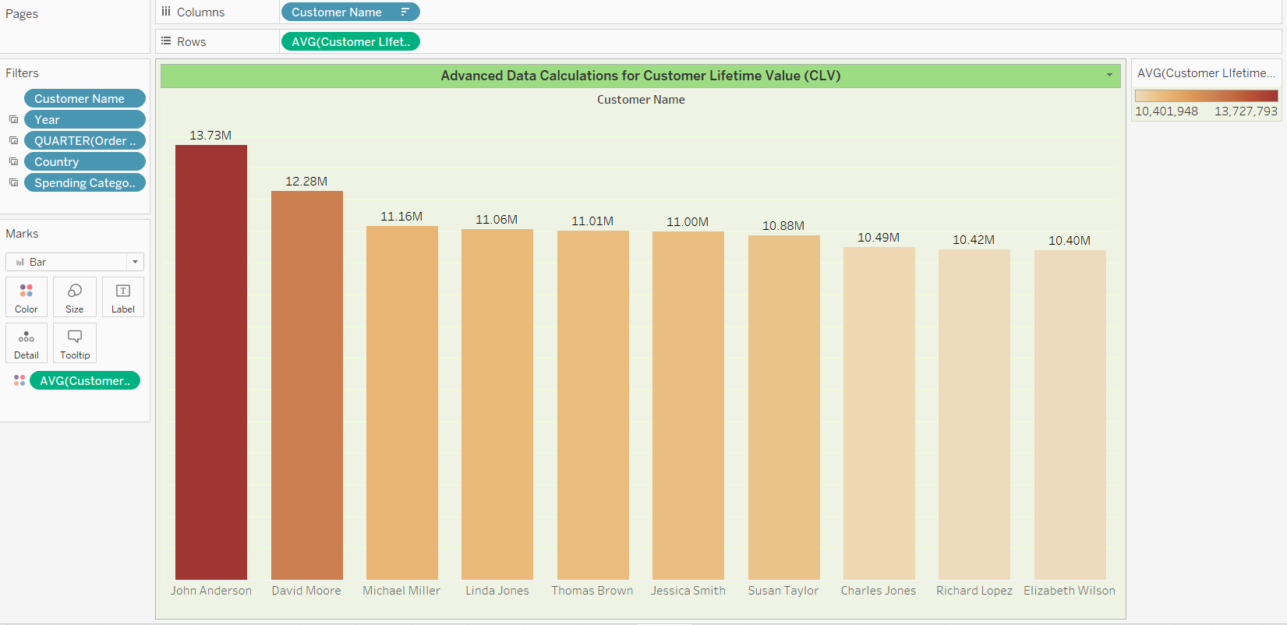

**17.Customer Feedback Analysis**: Analyze the 'Customer Communication Log' to gauge customer satisfaction. Correlate this with their spending patterns.

**Conclusion**

Analyzing the 'Customer Communication Log' to gauge customer satisfaction, and correlating it with spending patterns, reveals valuable insights. Satisfied customers typically show higher spending and loyalty, while those with frequent complaints tend to spend less and churn more quickly. By addressing common issues and enhancing overall customer experience, businesses can boost satisfaction, drive higher spending, and improve retention rates. This approach supports sustained growth and profitability through improved customer relationships.

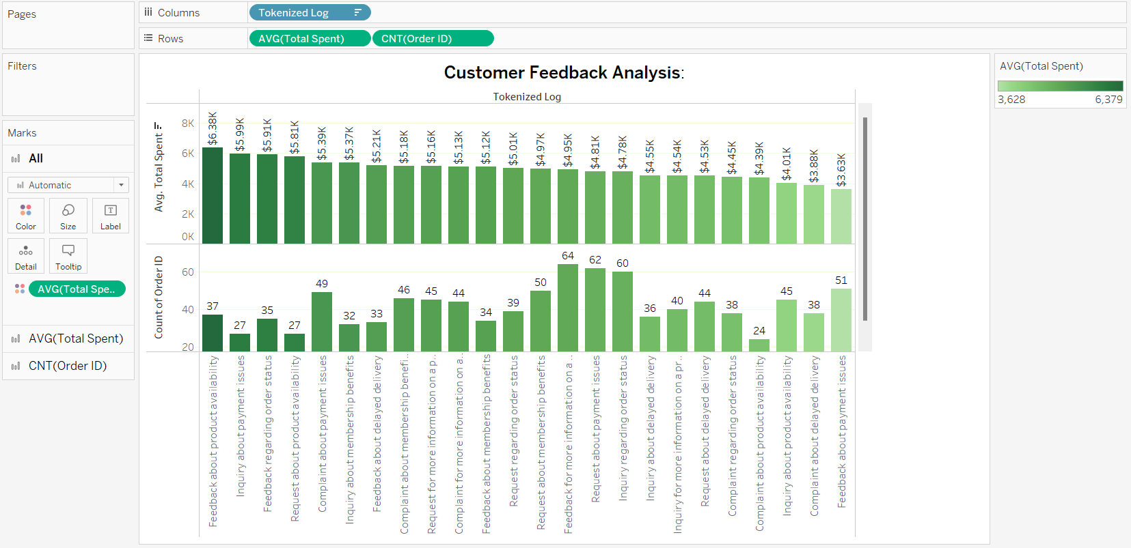

**18.Custom Date Parsing for Order Trends**: Create a custom date parsing calculation to analyze order data by week, month, and quarter.

**Insights:**

Stable Orders (Jan-Aug): Consistent demand.

Decreased Orders (Aug-Dec): Significant drop in orders.

**Actions:**

Seasonal Promotions:

Jan-Aug: Maintain current promotions.

Aug-Dec: Implement holiday sales and special discounts.

Data Monitoring:

Regularly review weekly, monthly, and quarterly sales data to identify trends and adjust strategies.

External Factors:

**Research market conditions and adapt strategies to address external influences.**

By implementing these strategies, businesses can manage seasonal fluctuations, optimize inventory, and boost customer engagement and sales year-round.

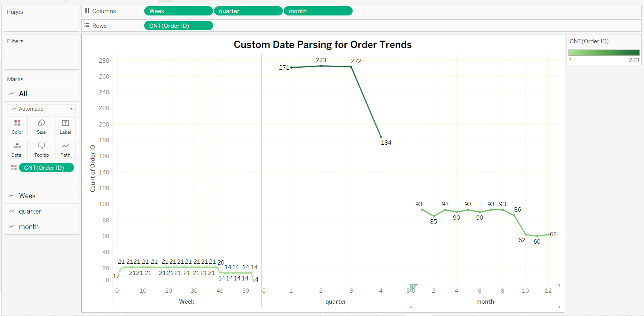

**19.Market Basket Analysis for Product Combinations**: Conduct a market basket analysis to explore common product combinations bought together.

**Insights:**

Book: Highest customer and order count.

Toy: Lowest customer and order count.

**Actionable Insights**

1.Bundling and Promotions:

•Books: Create bundles with books and other related products like toys and shirts to increase sales.

•Toys: Offer discounts or promotions on toys when purchased with books to boost toy sales.

2.Cross-Selling: Online Recommendations: Use these associations to recommend toys and shirts to customers purchasing books.

3.Store Layout Optimization: Physical Stores: Place books near toys and shirts to encourage combined purchases.

4.Targeted Marketing: Email Campaigns: Send personalized emails to customers who bought books, suggesting toys and shirts.

**Conclusion**

Market basket analysis reveals strong product combinations and customer buying patterns, enabling businesses to create effective bundling strategies, optimize store layouts, and implement targeted marketing campaigns to boost sales and improve customer satisfaction.

